LAB 10 , 11 : Q1.
A city’s emergency response system needs software to manage
incoming incident reports. Each incident has a (higher value means more severe), a
indicating when it was reported, and a short . Emergency units must always be dispatched
to the most severe incident available; if multiple incidents share the same
severity, the one reported earlier should be handled first. Write a C++ program
that uses a
to manage these incidents. Your program should accept a sequence of operations:
"ADD
severity timestamp description" to add a new incident, and "DISPATCH"
to remove and print the next incident to be handled. If a dispatch is requested
when no incidents are available, print "NO INCIDENTS".
Design the priority queue so that it orders incidents correctly using the
heap’s properties, and demonstrate the system with sample input and output.
Q2.
A social media platform wants to detect and block duplicate posts
to reduce spam. Each post is represented by a string containing text written by
a user. Because millions of posts are processed every hour, storing all posts
directly is inefficient. Instead, the system will generate a for each post and store it in a hash
table to quickly check whether the same post has already been submitted. Write
a C++ program that uses a hashing technique (such as unordered_set or a custom
hash function) to read a series of post strings from input. For each post,
output "NEW" if it has
not appeared before and store it in the hash table; otherwise output "DUPLICATE" if the post
already exists in the table. Ensure your approach handles large input efficiently
and avoids unnecessary collisions. Demonstrate your solution with sample input
and output.

Q1: 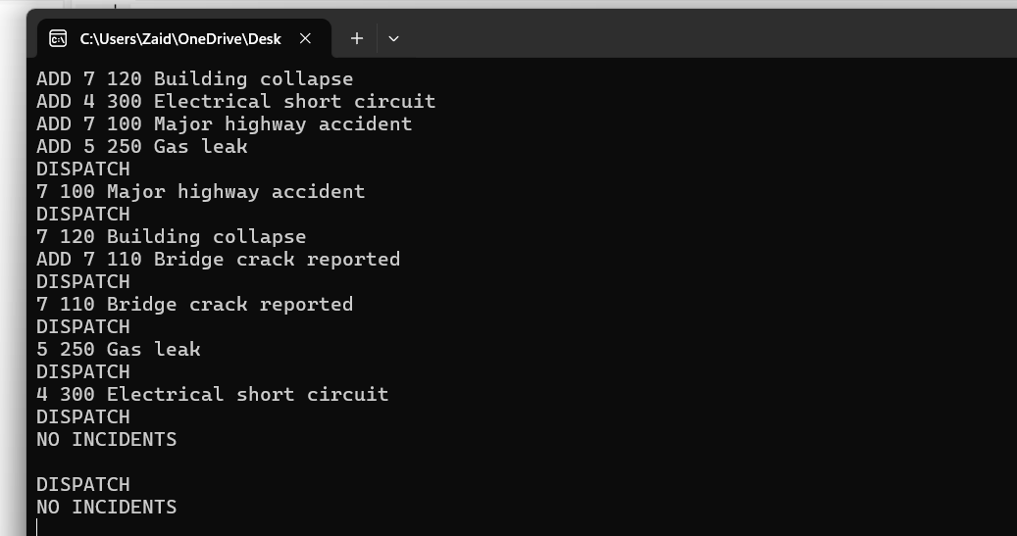

Q2: 